PROJECT REPORT ON

GOVERNMENT ARTS AND SCIENCE

COLLAGE

Submitted by

ABARNA

ANUSIYA

ANUMANTHIRA

DINAKA

UNVEILING MARKET INSIGHT:ANALYSING

SPENDING BEHAVIOUR AND IDENTIFYING

OPPORTUNITIES FOR GROWTH

1.INTRODUCTIOIN:

1.1 Over view

Understanding your consumers needs and wants has become essential to ensure your company is future proof.

Listening empowers you to learn from and talk to your customers in order to create ever improving experiences.

Business with quality data are more likely to collect actionable customers insights

1.2 Purpose

Wholesaling is buying goods in bulk quantity, ususally directly from the manufacture or source at a discounted rate.

The consumption and production of marketed food are spatially separated.

The primary objective of this project is to understand customer spending patterns, preference, trends across various dimensions.

2.PURPOSE DEFINITION &DESIGN THINKING

2.1 Empathy Map

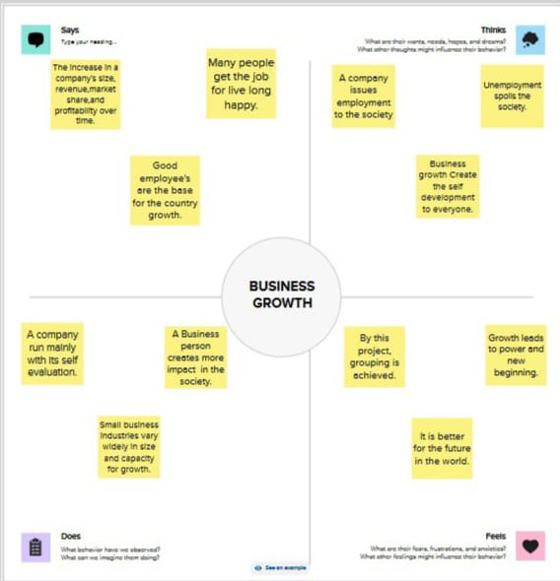

2.2 Brainstroming Map

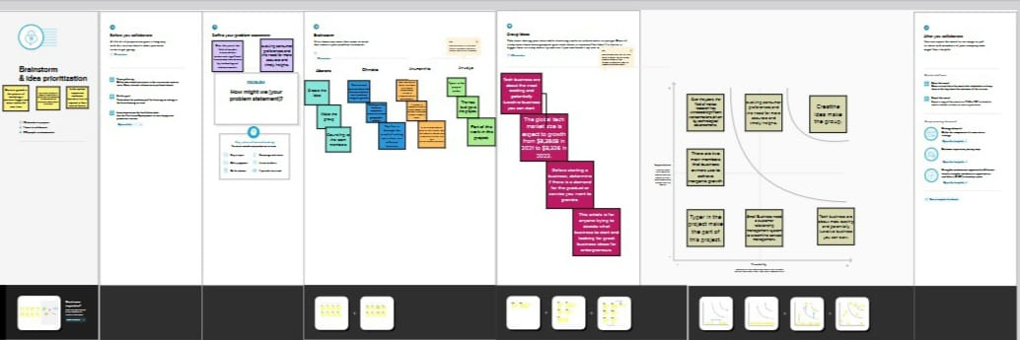

3.RESULT



4.ADVANTAGES

We utlised a multiple-design case approach and selected eight buyers and their Suppliers from the textile industry.

In competitive relational settings the trial resilience level is lowest, and when the relational dynamics are co-operative the trial resilience level is moderste.

Our insights from cases are among the first attempts to link three types of supplier-supplier relational dynamics to trial.

5.DISADVANTAGES

Drawback of observational research is the risk of bias and subjectivity in the data collection and analysis process.

Bias can occur when the research or the observe has preconceived notions, expectations, or preferences thet influence what they observe, how they interpret it, or how they report it.

6.APPLICATION

A consumer insights is an interpretation of data used by businesses to gain a deeper understanding of how their audience thinks and feel.

When consumer insights research is conducted properly it should improve the effectiveness of how a company communicates to its customers.

But collecting good consumer insights can be challenging.

7.Conclusion

By conducting a comprehensive analysis business can optimize their marketing strategies, improve product offerings and enhance customers engagement to drive revenue growth.